•CERTIFIED ORGANIC•

Family Residences and Essential Enterprises, Inc. (FREE) supports and employs differently-abled individuals. Our farm, which is in its sixth season, is l00 percent certified organic. We are located on the property of the Sisters of Saint Joseph, 1725 Brentwood Road. Our entrance is located on the back road off 2nd Avenue, Brentwood, NY.

Our CSA (Community Supported Agriculture) is offering shares for the
2018 Season from June 4th thru October 29th. Throughout the season, 40 varieties of l 00 percent certified organic vegetables, herbs and flowers are included
in your share. Pick up at the farm will be on Tuesdays and Thursdays.
Full shares are $650; returning customers pay $550. Half shares are $350. There is a
$50 referral reduction for any fully paid referral. We accept cash, credit or checks.

Farm Stands Are Open From 11:00 a.m. - 2:00 p.m. for All Locations:
Tuesdays: United Veterans Beacon House
1715 Union Blvd., Bay Shore
Wednesdays and Thursdays: Freedom Farm at St. Joseph
1725 Brentwood Road, Brentwood
(Easy access off of 2nd Ave. - look for a sign)
Thursdays: Ade/ante of Suffolk County, Inc.
83 Carleton Ave., Central Islip

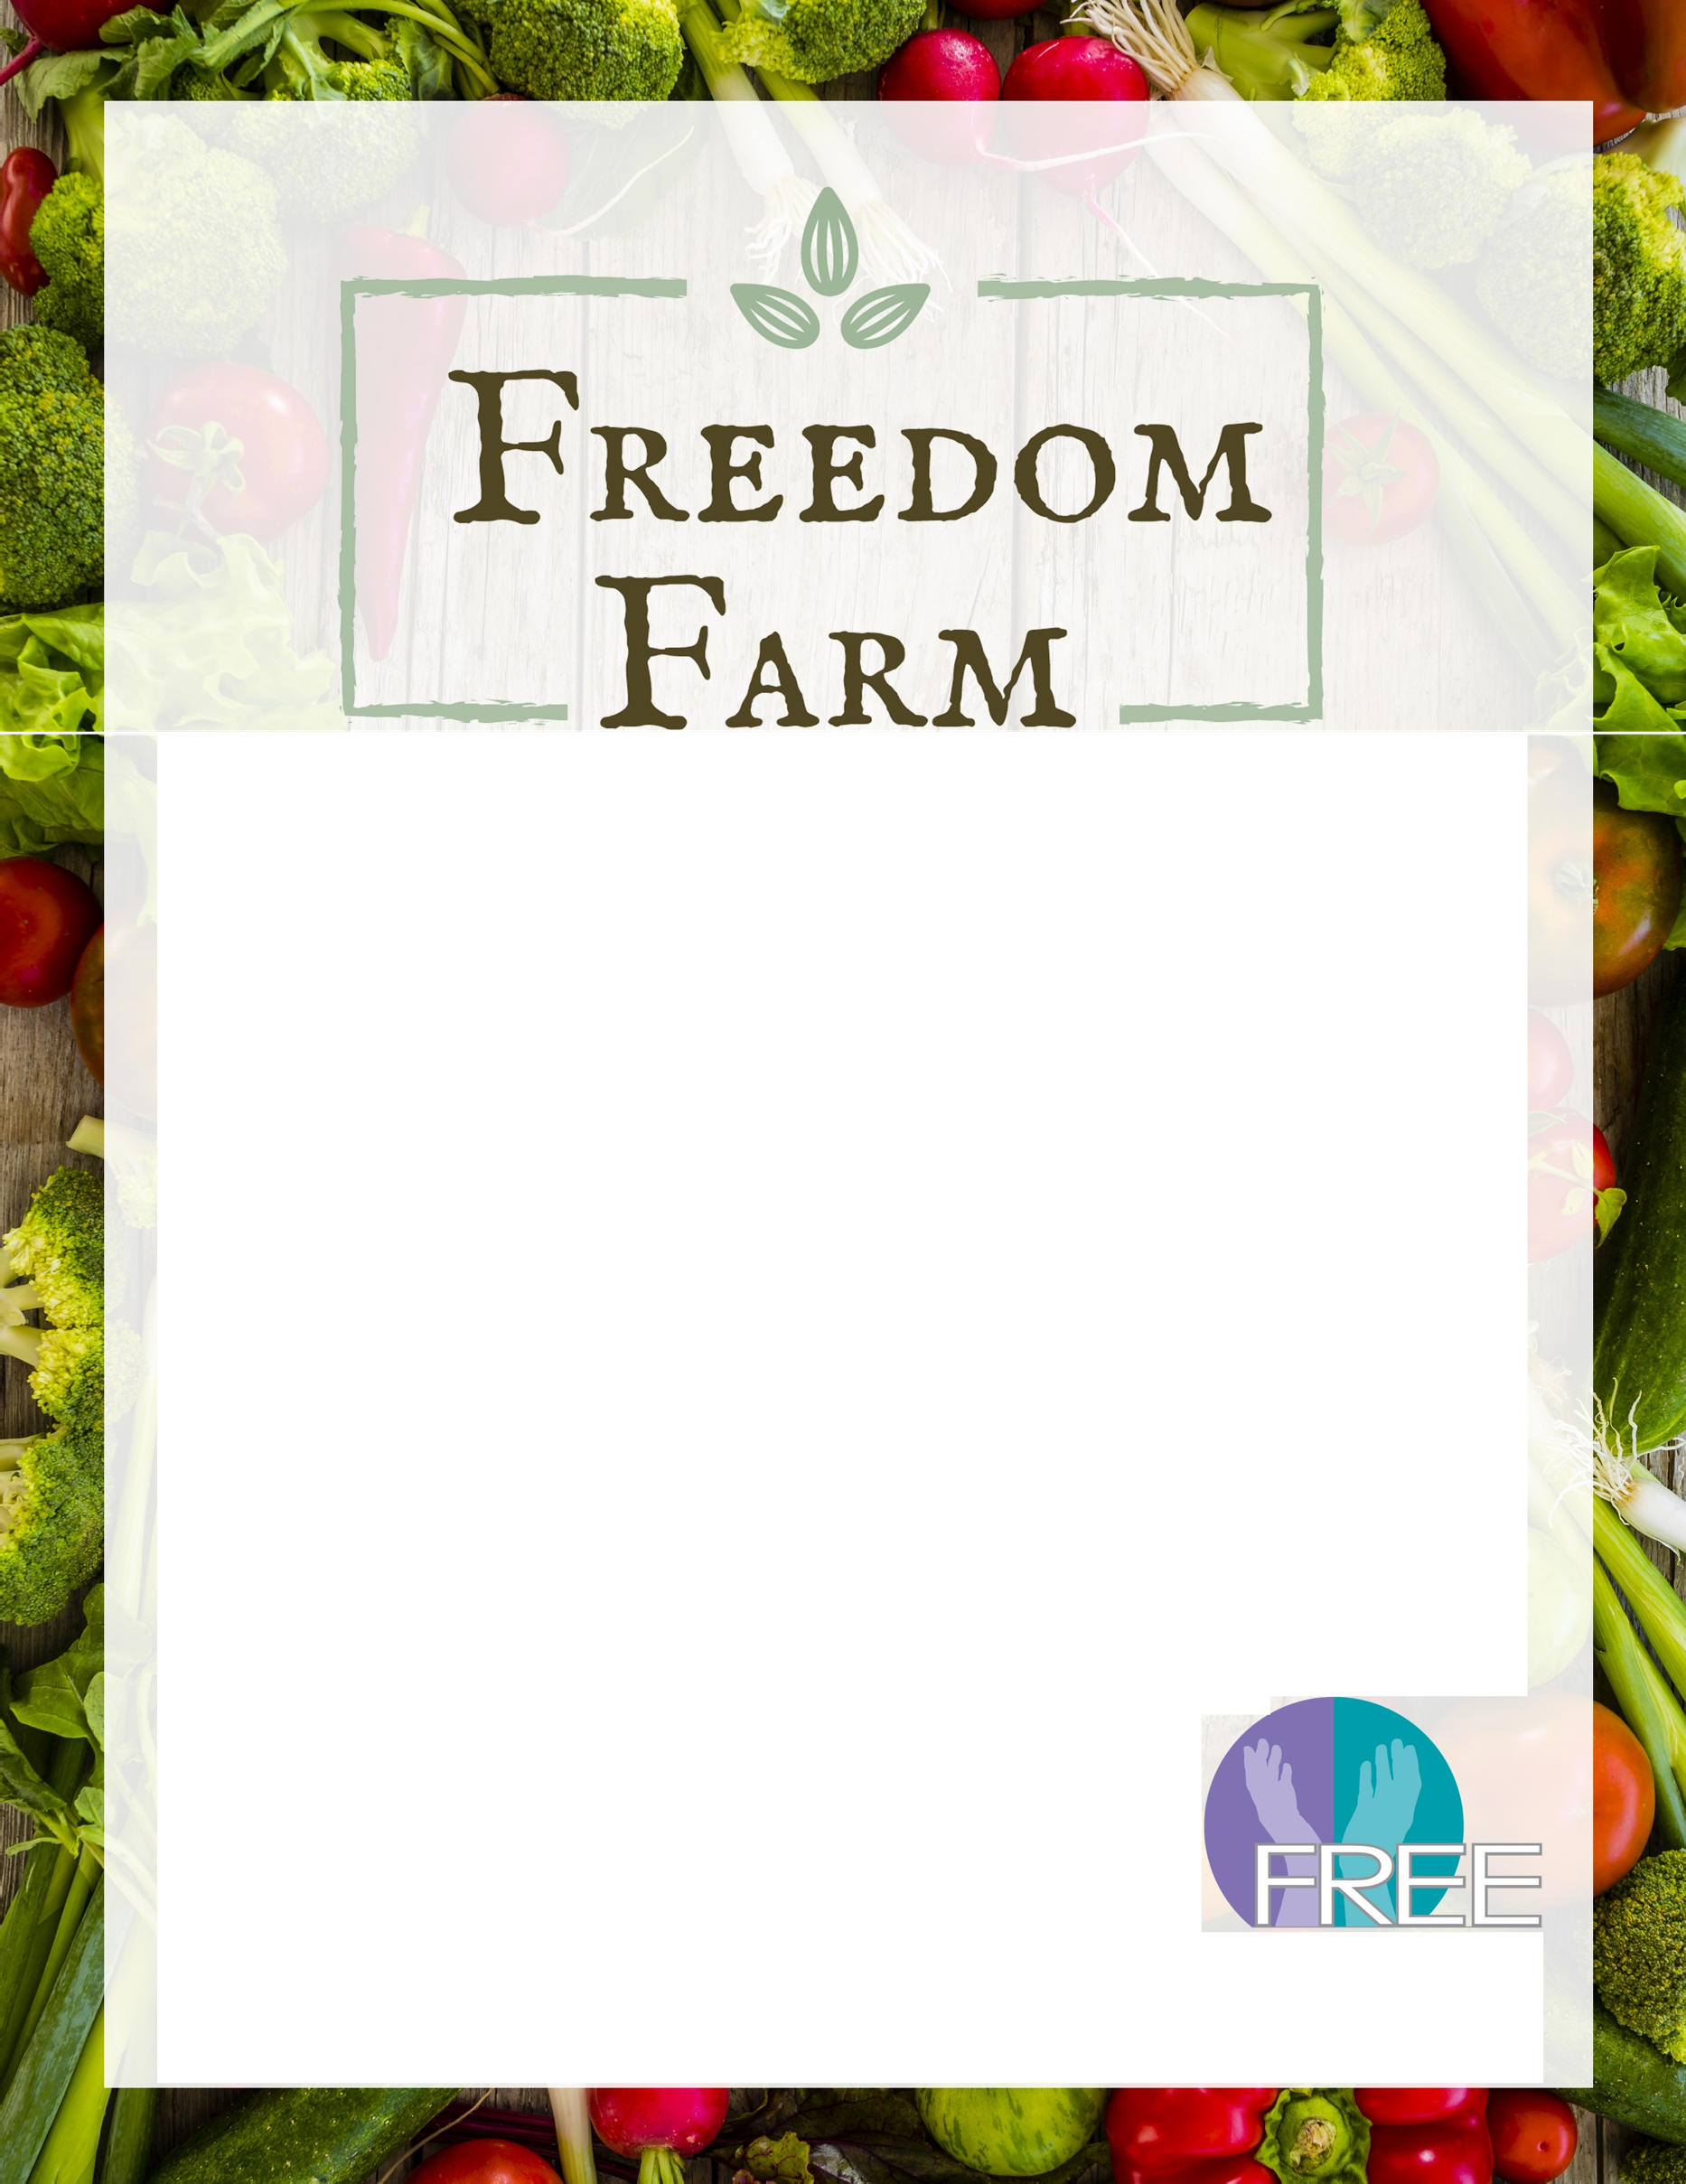
For more information, please contact:
Karen Bonne at 631-345-03 l 8 or thefarmer@familyre s.org .
Family Residences and Essential Enterprises, Inc.
Reach High I Achieve More

